MARKETING COPY FOR ADVISOR WEBSITES

This document provides marketing copy for Legacy clients in good standing to use on their website to describe their process. To obtain any of the graphics, gifs or videos, please reach out to us or connect us with your web designer and we’ll provide the files needed. Use of any of our graphics must have the registered or trademark symbols on them giving credit to The Legacy Companies.

Values-Based Planning
Discovery Leads to Wise Choices
You have individual experiences and unique hopes and dreams that call for a values-based approach to financial planning. Your core values become the basis for defining your financial philosophy and this serves as a guide in developing your plan.

The starting point for Financial Discovery is to separate two conversations that are often blended into one. Specifically, planning conversations can sometimes move too quickly to solutions, before taking the time to really understand what matters to you, and why it matters.

To address this, we separate the conversations using a concept called The Planning Horizon®. First, we explore what matters and why. Once we do, then we’ll work with you to develop a plan to achieve it.

Values: Your core values represent the rules by which you live your life.
Vision: Your desired future state.
Goals: The actionable steps that will make your vision a reality.
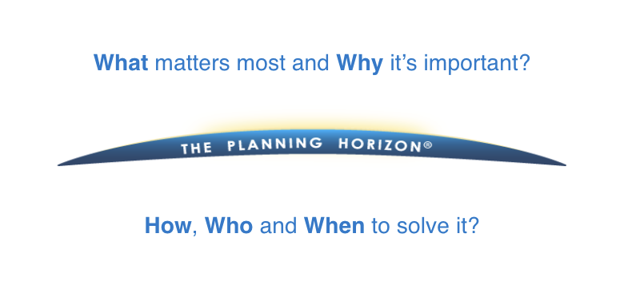

(The above image is an animated gif)

By starting above the horizon and discovering your values, vision, and goals, you will have the clarity and confidence you need as we create a plan to achieve it.

OUR PROCESS

As your advisor, we are compensated on a fee basis for the time and expertise put into designing and creating your personal financial plan. Under this fee structure, we have a responsibility to ensure your interests and goals are always put first.

(The above image is a video: https://vimeo.com/543211144/2c30533f5f)

Of course, our role with clients goes beyond just providing expert guidance in the creation of your financial plan. When we work with you during a financial planning engagement, we follow the fiduciary standard which means that we act in your best interest and put your interests ahead of ours. We’ll also help you implement your plan through a combination of innovative investment and insurance solutions, working in conjunction with your current advisors, and when necessary, helping you identify the right advisors who can fill a need we’ve identified together.

In the end, we are paid to work with you to make sure your financial needs are met with care, with expertise and with an understanding of your unique circumstances and individual goals. Together, we can agree on the appropriate fee structure based upon those needs and the specific services required.

Making great decisions about your wealth, whether you are deciding to grow it, protect it, or both, starts with sound thinking: thinking that makes sense. Here’s how our thinking starts when it comes to helping you make important financial decisions.

With financial independence, family legacy and social capital solutions in place, wealth optimization becomes the focus of the planning process. We use a unique and disciplined values-based approach to help you make wise choices and to help ensure that your plan is focusing on what you value.

We break the planning process into four quadrants or phases, each one representing one planning cycle: Discovery, Creative Solutions, Strategy Deployment, and Results Management.

- Discovery: The first phase begins by clarifying your core values, the vision you have for the future, and the goals that will move you closer to achieving that vision. This is called the Discovery phase.

- Creative Solutions: The second phase is the Creative Solutions phase where we think clearly about the solutions and make decisions regarding closing the planning gaps towards achieving your goals.

- Strategy Deployment: The third phase is the Strategy Deployment Phase where we implement the solution and help achieve your desired results.

- Results Management: The final phase is the Results Management phase where we establish a plan to manage and implement the results. This assures you have confidence your plan will work over time.

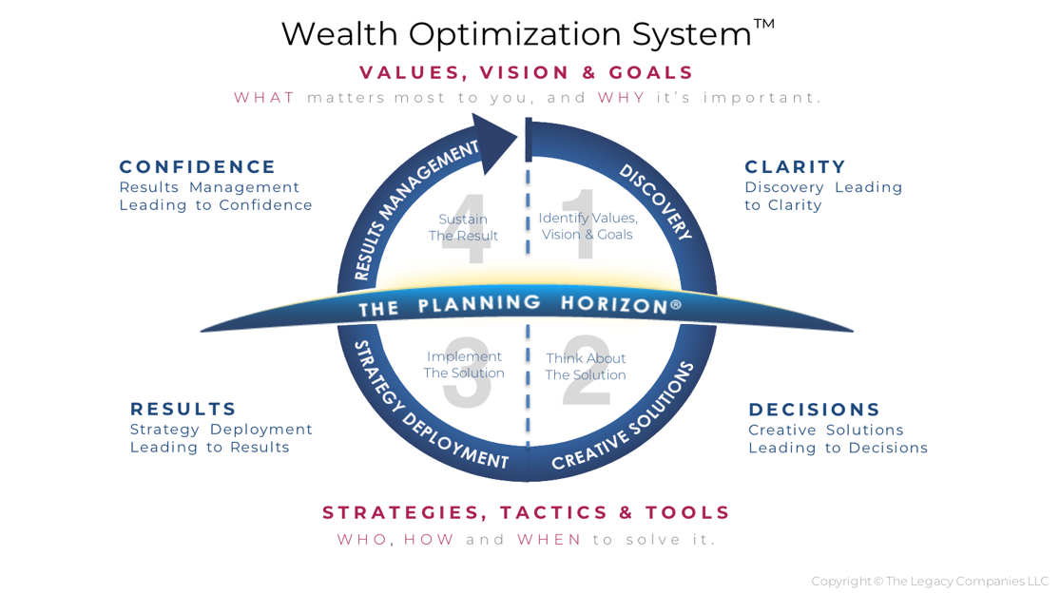

(The above image is graphic)

Working with a knowledgeable and experienced planner who has access to current technologies and a thorough understanding of tax rules and financial planning techniques is important. Working with an advisor who takes the time to understand your unique desires and goals is critical.

We will take the time to help you make that assessment, develop a plan that works for you, and provide you with the tools and strategies necessary to successfully implement the plan.
(The above image is a video: https://vimeo.com/736614739/2a4c7fa929)

ADVANCED/ESTATE Planning

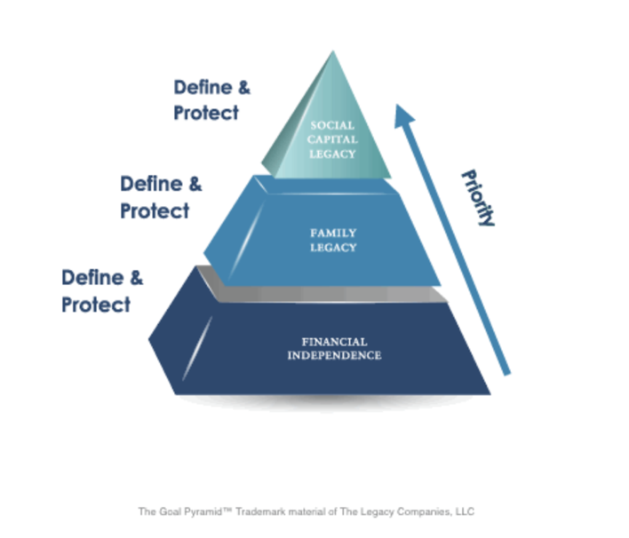
Natural Priority of Planning

The planning process is driven by three intrinsic objectives:

1. The need for financial independence
2. The desire to leave a family legacy
3. The desire to have a positive impact on society through a social capital legacy

(The above image is an animated gif)

Your plan should maintain your desired lifestyle and protect your financial security, transfer what you have to whom you want, when you want and how you want, and allow you to choose between charitable or tax dollars.

Navigating the Life Stages

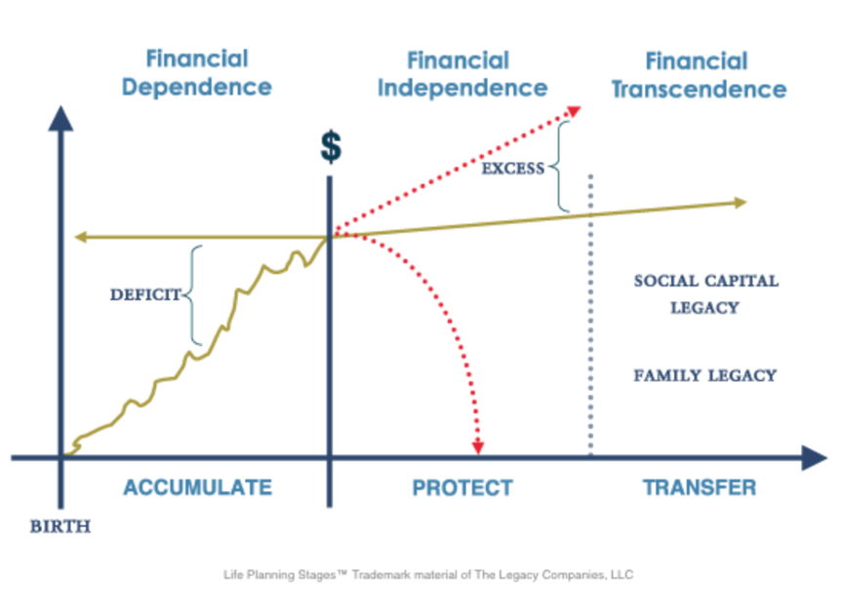

(The above image is an animated gif)

Financial Dependence
We all start at birth. This begins the wealth accumulation phase of life. During this phase, we are financially dependent. Initially, we are dependent upon our parents. As we become young adults, our dependence shifts to ourselves, and our ability to generate wealth through employment earnings or building a business. The focus of this phase is wealth accumulation. For most of us, during the Financial Dependence stage, we must work for money - to generate the desired lifestyle and protect our financial security.

Financial Independence
The second line illustrates the point where you achieve Financial Independence; when your financial resources are sufficient to support your lifestyle and protect your financial security. At this point, your money begins to work for you, and you have the freedom to buy back your time to create the calendar you desire. Once Financial Independence is achieved, the rules of the game change. With regard to your financial independence, the objective becomes defendable growth. Protect the base and limit the risk.

Financial Transcendence
The dotted line makes the boundary between independence and transcendence. This is our final opportunity to apply our wealth creatively and effectively for the benefit of others. It is where our financial resources transcend ourselves and are used for the benefit of our heirs or society at large. Family Legacy is where you allocate resources to your heirs. Social Capital Legacy, traditionally thought of as philanthropy, is where you allocate resources to benefit others.

The Allocation of Excess Wealth
Every dollar accumulated above your financial independence goal is essentially unproductive unless used to accomplish a meaningful goal. We refer to these dollars as Excess Wealth. There are four potential uses for excess wealth:

• To improve your lifestyle. Is there anything you desire to complement or complete your current lifestyle?
• To keep playing the game. What is left on your list of things to accomplish in life?
• To provide security and opportunity for your heirs. How can you use your financial resources to positively impact the lives of your heirs?
• To provide security and opportunity for others. How can you use your financial resources to positively impact the lives of others?

Our objective is to help our clients create and effectively deploy
excess wealth in a manner that accomplishes their greatest goals, dreams, and desires.

